**DIS-**Jurassic-Araucaria mirabilis

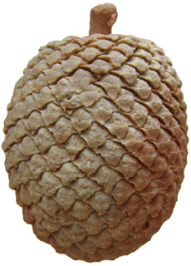  
*Araucaria mirabilis*Jurassic Santa Cruz, Argentina   
6.5cm wide x 8.5cm long